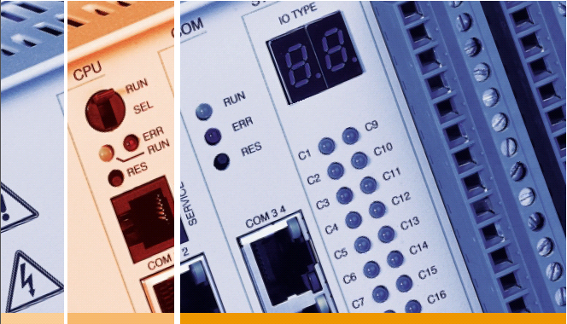

IDS Telemetry

**RTU Simulator – IEC 101 Slave  
  
Manual**

**Copyright**

Copyright © IDS GmbH All rights reserved.

Reprints or copies of this document may not be made, even in part.

This document may not be reproduced in whole or in part, in any form (photocopying, microfilm or other processes), nor may it be electronically processed, reproduced or distributed, even for the purpose of lessons or instruction, without the written consent of IDS GmbH.

We reserve the right to claim damages in the event of infringements of the above.

IDS GmbH

Nobelstraße 18

D-76275 Ettlingen

**Disclaimer**

Some of the functions described in this document are optional, in the sense that only certain product versions include these functions. Other functions not described in this document may be capable of running in the system, but we are unable to provide any guarantee for these functions.

The content of the documentation is checked regularly. Any necessary corrections are contained in subsequent editions.

We reserve the right to make technical modifications.

Table of Contents

1 General 4

2 Overview. 5

2.1 Slave Control Panel 5

2.2 Item Panel 6

2.3 Status Panel 7

2.4 Supported IEC Types 7

3 Configure Slave 9

3.1 Define Type Names 9

3.2 Define Information Objects 11

3.2.1 Monitoring Items 11

3.2.2 Control Items 11

4 Start Communication 12

4.1 Configure serial port 12

4.2 Configure Link Address 13

4.3 Persistent settings 13

4.4 Event Buffering 14

5 Send Information Objects 15

5.1 Value Dialog. 15

5.2 Quality Dialog. 16

5.3 Configure simulation parameters 18

6 Load Items from File 19

# General

This IEC Slave is a software to simulate the slave side of systems using the serial  
telecontrol message protocol specified in the [IEC 60870-5-101](http://en.wikipedia.org/wiki/IEC_60870-5) standard.

This software responds Information to Master Requests (IEC 60870-5-101 Master) on a defined Link address.

The software allows to simulate certain IEC ASDU types manually or to configure automatic value simulation in cyclic periods.

# Overview.

After start of the IEC slave you will see on the Application three main panels.  
The panels are:

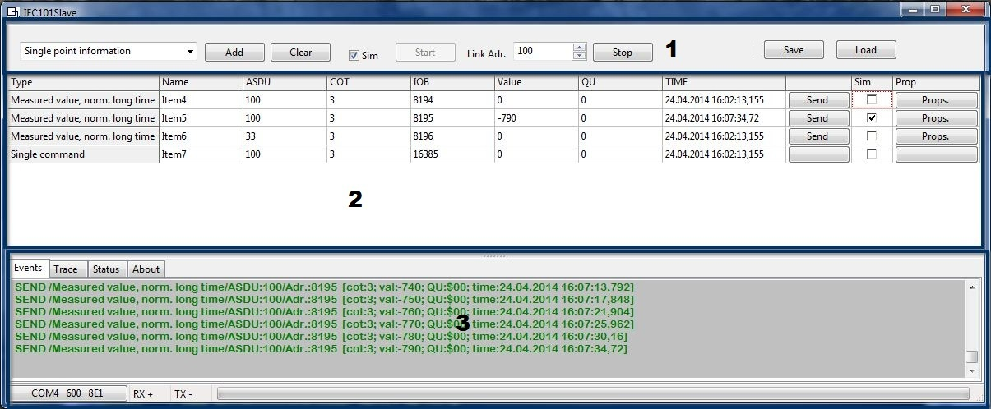

1: Slave Control Panel

2: Object Control Panel

3: Slave Status Panel

## Slave Control Panel

On top of the window is the Slaver Control Panel.  
Elements of the Server Control Panel are:

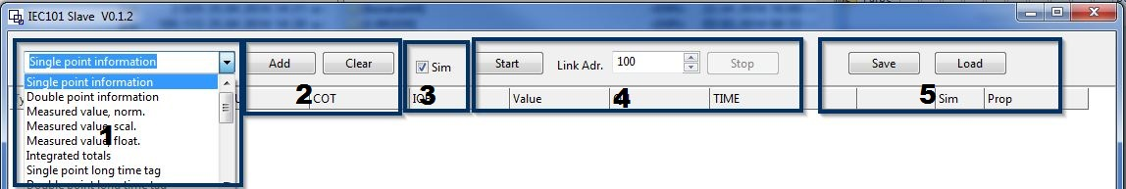

1: Combo box to select the IEC Type that should be added to the list of simulated items.

2: Button to add selected IEC Type to Item Simulation List and Button to Clear the complete List.

3: Master Enable Option for automatic Item Simulation

4: Buttons to Start and Stop Slave and respond on the selected Link Address.

5: Button to Load Item lists.

## Item Panel

The center part of the window shows the Item Panel.  
The meaning of the columns in the Item Panel is as follows:

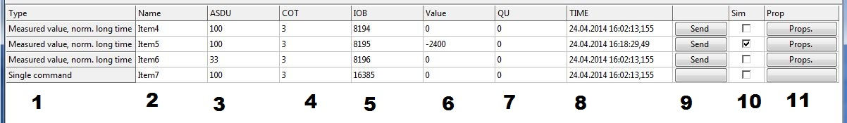

1 : shows type of IEC items   
2: click here to change user defined description of the IEC Item   
3: click here to change Common Address of ASDU   
4: click here to change COT

“*Indicates causes of data transmissions like spontaneous or cyclic”*5:click here to change IOA Information Object Address   
 “*Provide address of the information object element”*  
6: click here to change current Value of the IEC Item   
 “(possible value depends on Item Type) “  
7: QU Bit set of Item Quality (available Bit set depends on Item Type)  
8: shows Time of last change of the item Value.  
9: click Button to send the current Item information to Client   
 only available for items in monitoring direction.  
10 Check Box to enable Automatic action for the Item  
 Items in monitoring Direction: change value of this Item.  
 for Items in control direction can no action assigned  
11: click Button to configure automatic simulation actions.  
 for Items in control direction can no action assigned

## Status Panel

The bottom part of the window shows the Status Panel  
The Status Panel has different Tab sheets.

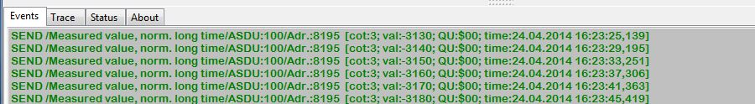

e.g. TAB “Events” - here you can observe the data transmission between IEC Slave and connected Master and see some warnings and alarms.

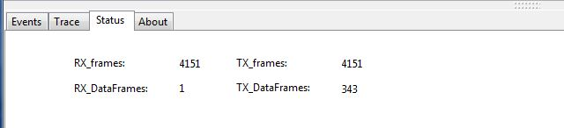

e.g. TAB “Status” here you can see some transfer statistics of master Client communication .

## Supported IEC Types

For the IEC Slave the currently supported ASDU types are :

**Process information in monitoring direction :**

M_SP_NA = Single point information  
M_SP_TB = Single point long time tag  
M_DP_NA = Double point information   
M_DP_TB = Double point long time tag   
M_ME_NA = Measured value, norm.   
M_ME_TB = Measured value, norm. long time   
M_ME_NB = Measured value, scaled.   
M_ME_TD = Measured value, scaled long time   
M_ME_NC = Measured value, float.   
M_ME_TF = Measured value, float. long time  
M_IT_NA = Integrated totals   
M_IT_TB = Integrated totals long time

**Process information in control direction :**

C_IC_NA = (General) Interrogation command   
C_CI_NA = Counter interrogation command   
C_CS_NA = Clock synchronization command   
C_SC_NA = Single command   
C_DC_NA = Double command   
C_SE_NA = Set point command norm. value   
C_SE_NB = Set point command scaled value   
C_SE_NC = Set point command float.

# Configure Slave

## Define Type Names

I recommend first to give a clear description to the different Types.

To define the description of Types put an “IEC.ini” file in **the same Folder** as the application.

Define in “IEC.ini” file an Section “[TypeName]” you can now define the description the IEC Slave should use for the different Types

e.g. a file content:

*[TypeName]  
M_SP_NA = Single point information  
M_SP_TB = Single point long time tag   
M_DP_NA = Double point information   
M_DP_TB = Double point long time tag   
M_ME_NA = Measured value, norm.*

*…*

will result in:

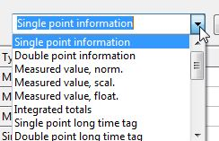

And this file contents:

*[TypeNameRaw]*

*M_SP_NA = IEC Type 01  
M_SP_TB = IEC Type 30   
M_DP_NA = IEC Type 03   
M_DP_TB = IEC Type 31   
M_ME_NA = IEC Type 09   
M_ME_TB = IEC Type 10*

will result in:

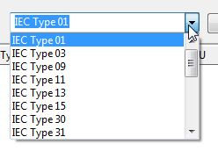

Without the IECTypeDescription.properties file or if a Type is missing in the file you will see the Standard Type Descriptions like:

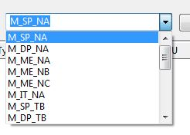

## Define Information Objects

### Monitoring Items

Now start to define the **Information Objects** you wish to simulate**.**Select on the Slave Panel combo box a Type you wish to add and press the add Button. Then adjust the ASDU and Information Object Address (IOA) by clicking into the corresponding cell .

|  |  |
| --- | --- |
|  |  |

Define a name to an item is optional.

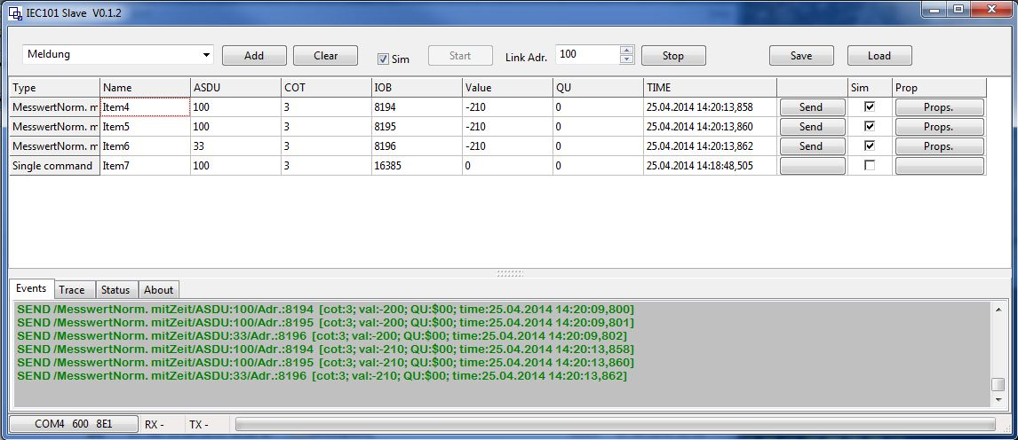

### Control Items

Received Items in Control Direction (e.g. commands, set points)  
**will be replied from Slave**.

If there are not defined in Item Panel thy will replied with COT:=$47

If there are defined in Item Panel thy will replied with COT:=$07

# Start Communication

## Configure serial port

Serial settings are shown left in the Status bar:

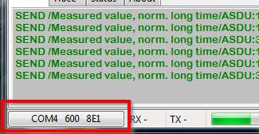

To change serial settings press this button in Status Bar.

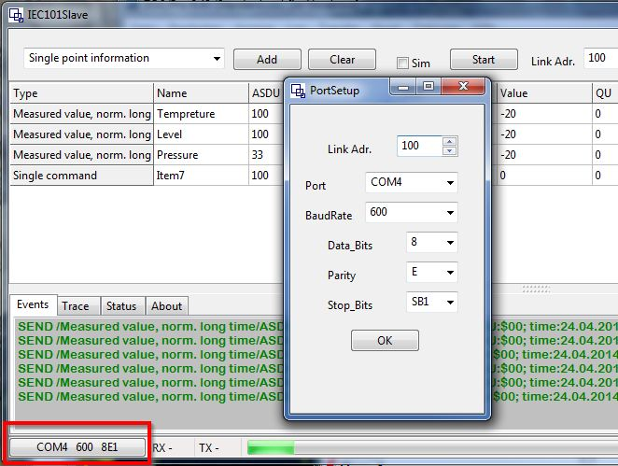

A Change of the serial setting is only possible if the Slave is in Stop Mode.

After that you can switch the IEC Slave to Listen Mode and make him available for an IEC101Master (usually a IEC Gateway System ) by press the Start Server Button on the Slave Panel.

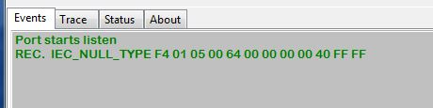

## Configure Link Address

The Slave only Responds to Master Request to his Link address.

Against serial settings, Link Address can still chanced while the Slave is runnig.



## Persistent settings

Next Time when you startup this Program it will continue with the defined settings.

The settings are stored in “IEC.ini” file in **the same Folder.**

Also you can edit the settings manually section Name in File is “Config”

*[Config]*

*LinkAdr=100  
Port=COM4  
BaudRate=600  
DataBits=8  
Parity=E  
StopBits=0*

## Event Buffering

If the frequency of item changes to fast for the chosen Baud Rate (or if the communication not run at all) the Updates are stored in an buffer until the can be transferred.

The usage of the buffer can be seen in the status bar.

buffer.jpg

# Send Information Objects

If at least one client is connected the server can start sending IEC messages

Click “Send” Button in the Item Panel to send the Item with current value and quality   
The time stamp will be added.  
Mark the “Sim” check Box to start automatic value changes.  
Click on “Value” or “QU” table cell to change the item value or Quality .After change the item will be sent automatically with the new parameters.

## Value Dialog.

Different IEC types have Different Dialogs for manual value change

Single Signal Dialog 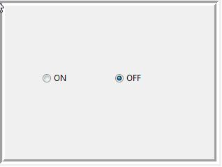

Double Signal Dialog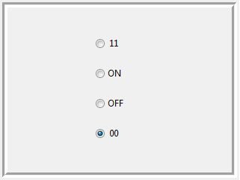

Measurements Dialog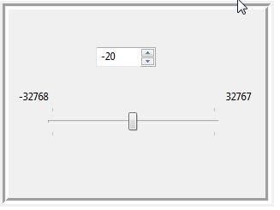

Integrated totals Dialog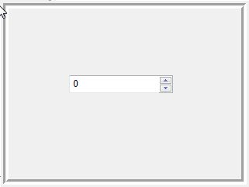

**All dialogs can be cancelled with the “ESC” key.**  
Any value change will directly assigned to IEC Item and the dialog will be closed.

## Quality Dialog.

Also like Value Dialogs different IEC types have different Quality dialogs for manual change.

Signals (single and double)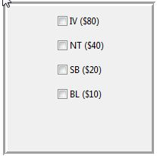

Measurements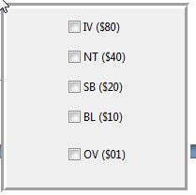

Integrated totals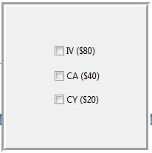

**All dialogs can be cancelled with the “ESC” key.**  
Any value change will directly assigned to IEC Item and the dialog will be closed.

For the meaning of the different quality flags pls. refer to the IEC 60870-5 standard.

## Configure simulation parameters

As already mentioned the “Sim” check Box in the Item Panel has to be check for the corresponded Item to enable automatic value changes.

To configure the behavior of a value change press the “SIM-Param.” button.  
This will bring up a dialog for simulation parameters.

Parameters for types in Monitoring Direction.

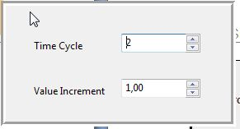

Field Time Cycle:  
sets the Time Parameter for Cyclic value change.  
e.g.  
 Time Cycle: 5 🡪 Cycle time every 5 sec.

Field Value Increment:  
 sets the Value that should added to the current item value every cycle.

# Save and Load Items to/from File

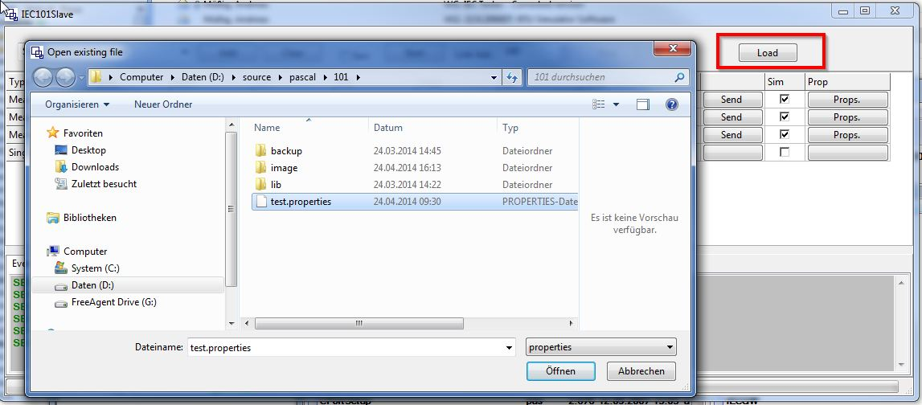

Example for an Item file

*FILE.VERSION=2*

*ITEMS.COUNT=4*

*ITEM.PROPERTIES=NAME;TYPE;ASDU;COT;IOB;VALUE;SIMULATE;SIM.PROPERTY;SIM.VAL_INC*

*ITEM1=Item4;10;100;3;8194;32197.0;true;+4;-10.0*

*ITEM2=Item5;10;100;3;8195;32187.0;true;+4;-10.0*

*ITEM3=Item6;10;33;3;8196;32247.0;true;+4;-10.0*

*ITEM4=Item7;45;100;7;16385;32227.0;false;+4;-10.0*

## Import CSV Files from ACOS ET

The software allows also to import csv files from ACOS ET to be imported.

